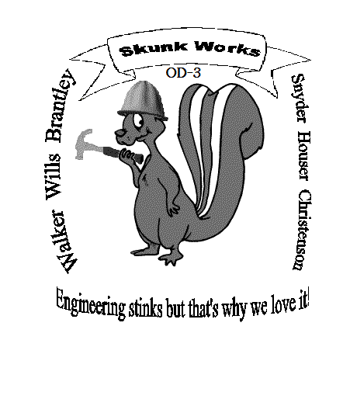
April 24, 2003

Problem Statement:
In the second semester of Engineering Fundamentals 102 at the University of Tennessee, each team has to solve and construct a projectile motion device. The device has to fit inside a 2 ft by 2ft by 2ft starting box and launch a paintball a certain distance where it aims to hit a moving particle. The particle is moving perpendicular to the launching pad at varied velocities that range from 0.2 to 0.8 ft/s. The particle also runs on a path of three varied distances of 20, 25, and 30 feet from the launch in the perpendicular direction and 5 feet in the parallel direction. The launching device must be activated at the same time as the particle and simultaneously launch the paintball to hit the particle. A four-foot high wall will also be placed at a distance of ten feet perpendicular to the launch. The paintball must clear the wall and hit the target. The launching device will be tested against two varied distances and velocities. The first attempt will be a set distance of 30 feet and 0.8 ft/s for each team. The second attempt will be a wild card distance and velocity and will be drawn before the second launch attempt. The device cannot be touched after the initial set for launch. A materials list was also given. Teams were allowed to petition the list and add additional items at the professor’s discretion. Our team, OD-3, decided to stick to the given list and did not petition any items. The materials list is as follows: 1 sheet of foam core, 4 ft of “bridge wood stock, 4 ft of duct tape, 6 ft of twine, 2 yardsticks, 1 #108 rubber band, ½ pound of small weights, 1 mouse trap, 1 4 ft ¼ inch dowel, 6 paper clips, 4 small nails, 3 oz Elmer’s glue, 2 pipe cleaners, and 1 small spring. A pictorial description of the launching area is provided below.

Background Information:
To begin this project our team began with research. We searched the Internet for similar projects and their performance. We found a number of comparable projects performed by other engineering colleges across the nation. The University of Cincinnati students had to build a trebuchet and launch it twenty yards in a straight line. This device could be no larger than two feet tall. This information was found at the website of www.uc.edu/news/trebuche.htm. Another school also had to build a trebuchet and hurl a twenty-pound object thirty feet. This information is found at http://andy.trebuchet.com/trebplan.pdf. While researching we found that the trebuchet idea seemed to be the most precise and strongest. It would also be the easiest to construct.
Possible Ideas
Still considering other ideas, team members began to make sketches of possible designs besides the trebuchet idea. Although the trebuchet proved to be the most accurate through research, we still wanted to explore other opportunities. The slingshot and bow and arrow were two other ideas proposed. The group decided a slingshot would be strong at launch but may not be as accurate. Fear of the paintball getting caught during launch was also a possibility with the slingshot. The bow and arrow would also be a strong launcher but may become too difficult to construct. In order to keep the device within the 2 ft by 2 ft by 2 ft requirements the bow and arrow was ruled out in fear of the device becoming too large. Team OD-3 decided to construct some sort of trebuchet or catapult.
After deciding on a trebuchet or catapult, team members began to make more sketches of possible designs. The team debated on how to vary the angle within the device to achieve an accurate distance. Two main ideas were considered and both are shown below. The first one is with the use of rulers on either side of the device. The ruler would be measured and marked. These measurements would indicate certain angles the catapult would have to be pulled to achieve a certain distance. The second idea, and the one chosen by the team, was the trebuchet idea. The launcher would be attached with strings to the base of the device. A certain length of string would indicate a certain angle the catapult would be stopped at to achieve the distance desired. The second idea was chosen because it seemed to be more reliable and accurate. In the second idea, three different strings of different lengths could be attached to the device in order to obtain the three different distances required. The first idea could fail because of human error, whereas in the second idea the strings are precut and just have to be attached for launch.
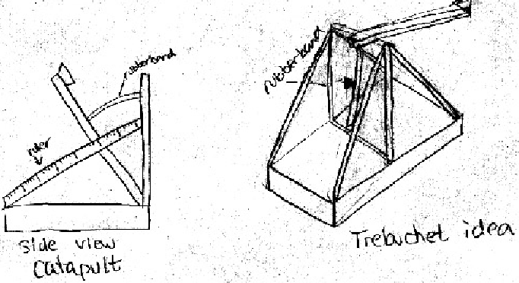
The timing device was also another debatable process within the team. Again two main ideas were considered and both are shown below in sketches. The first idea was one using a marble and ramps. The marble would roll down the ramps where it would eventually hit the mousetrap and trigger the catapult. The farther up the ramp the marble was placed the longer it took to reach the bottom and trigger the catapult. The next idea, and the one chosen by the team, was unique and original. This idea was one using three plastic cups, a lever, and some sort of counterweight. Two cups would be attached to either end of the lever while an additional cup would be attached above one of the cups on the lever. The cup attached above will have a hole in the bottom of it. Water or sand is poured into the cup with the hole. The water or sand then runs into the cup on the lever and when it obtains a certain weight the lever falls and triggers the mousetrap, which launches the catapult. The amount of counterweight on the opposite side of the lever decides how fast or slow the lever will fall and trigger the launch. Both ideas considered seemed to be fairly accurate. The lever idea was chosen because of uniqueness and creativity. This idea had not yet been thought of and tested by any other teams. With all decisions made, team OD-3 was ready to build and test their project.

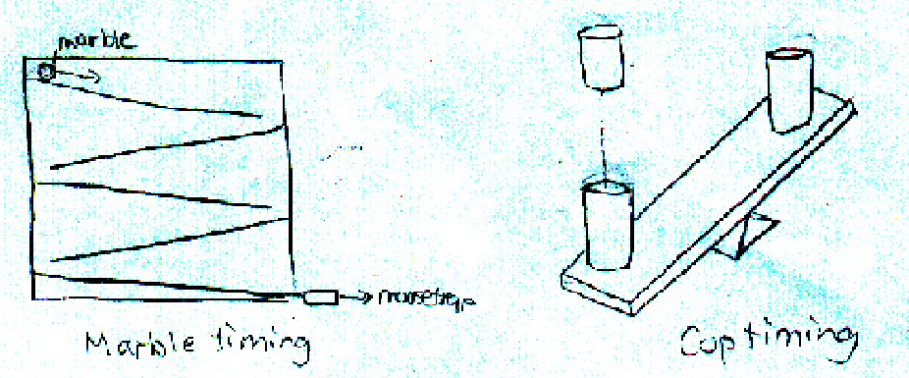
Final Design Description:
The final design of the trebuchet became very similar to the original idea decided upon. The base of the device would be made of wood for strength. Each joint is attached with nails. The launching part of the device will also be constructed of wood with PVC piping attached to the end to hold the paintball. The launcher will be attached to vertical wood elements with a dowel running through the center of it. The spring constant is a #108 rubber band and will be attached to the end of the launcher and the base of the device with wooden dowels. The three strings will also be attached to the base of the device and the opposite end of the launcher forcing it to stop and release the paintball to achieve a certain distance. The design is shown below at different views.
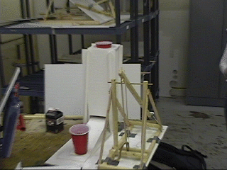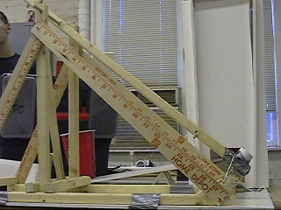

The final timing device decided upon is also very similar to the original one considered. The device is made of foam core, three plastic cups, a paper clip, water, and BB’s. The lever is made of foam core with two plastic cups attached to either end. The contraption to hold the cup with the hole in the bottom of it is also made of foam core. A plug, made of paper clips with foam attached to the end, was built to hold the water release. The paper clip not only acts as a plug but also a lever to trigger the release. The BB’s act as a counterweight and are placed on the opposite end of the lever. Once the plug is pulled, water releases from the top cup into the one below it. The water causes the lever to fall and trigger the mousetrap at a certain time. This amount of time depends on the amount of counterweight placed in the cup on the opposite side of the lever. A picture of the timing device is shown below at different views.
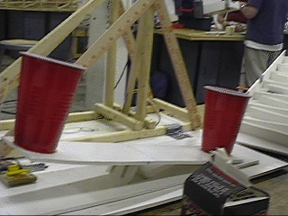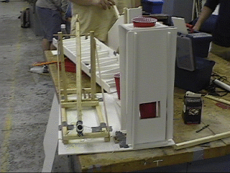
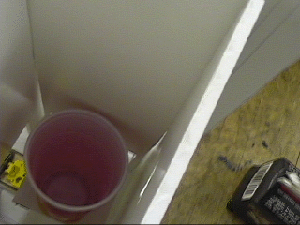

Testing of Final Design:
Before actual test day both the timing device and trebuchet had to be tested to calibrate. One of the team members in OD-3 designed a Matlab program to calibrate the trebuchet device. This program was used to decide what angles the launcher would need to be set at to achieve the three distances of 20, 25, and 30 feet. Once the angle was found the three different lengths of string could be determined and attached to the device. The program was also designed to determine the amount of seconds needed by the timing device at the certain velocities given. This program became very useful during calibration and testing of the trebuchet. Data is provided below of the angles and times determined by Matlab.

Target Distance (ft) Launch Angle (deg) Time in Air (secs) Initial Velocity (ft/s)
20 59 1.4 24
25 54 1.4 29
30 34 1.1 32
The timing device also had to be calibrated and tested to decide the amount of

counterweight needed to trigger the lever at certain times. The times were not only

determined by Matlab but also by hand using T=SV. The times for certain velocities are

as follows:
Velocity (ft/s) Time Delay (seconds)
0.2 25 s
0.3 16.666667 s
0.4 12.5 s
0.5 10 s
0.6 8.33333 s
0.7 7.14 s
0.8 6.25 s

A lengthy process of timing the amount of BB’s needed to achieve each time interval was found by testing the timing device. A time of 1.5 seconds was subtracted from the amount of original time desired because that is the amount of time tested to take the paintball to be launched and hit the ground. The results of the amount of BB’s needed to achieve given times is shown in a table below.
Amount of BB’s Time in seconds
154 bbs 23.5 s
109 bbs 15.166667 s
74 bbs 11 s
54 bbs 8.5 s
42 bbs 6.83 s
33 bbs 5.64 s
26 bbs 4.75 s

After all initial testing was done the trebuchet and timing device were ready for final testing day.
Conclusions and Recommendations:
Final testing day was on April 24th 2003, at approximately 10:30 a.m. Each team made two runs. The first run had a distance of 30 feet and velocity of 0.8 ft/s. The second run was a wild card run by each team. Our team drew a seven out of a deck of cards, which meant our second run was a distance of 25 ft with a velocity of 0.25 ft/s. The first run tested perfect in timing but was off five feet from the target. The second run again tested perfect in timing but was off three and a half feet from the target. Our timing device seemed to work to perfection but our accuracy in distance was off each run. We have decided the inaccuracy in testing is due to the stretch of the rubber band. New rubber bands have a different spring constant than stretched rubber bands. Our hole in the launcher was not drilled completely straight due to the absence of a drill press. This caused the paintball to launch a little to the right. If provided a drill press this would have fixed the accuracy of the shot being straight. In the future our team would have done more testing on the trebuchet with a new rubber band placed on the launcher each testing run. This would have concluded in a more accurate distance to hit the target. We also would have used better tools to drill our holes in order to achieve a straight launch. We would not change anything in the timing device because it proved to be accurate and precise each run. A lot of hard work and time was put into this dynamics project. Our team is proud of the results of our final team project in Engineering Fundamentals 102 at The University of Tennessee.

